**DBMS-1 Project :** RYNC.com( Rent Your Neighbor’s Car)

**Submitted by :**Srikanth Mandula

**FSU ID:** 3080786

**Submission Date :** 18th Dec 2016.

**DBMS-1 Project :** RYNC.com( Rent Your Neighbor’s Car)

**Description of Project and list of Assumptions :**

The project is to design a database for a company called RYNC.com. The business objective of RYNC.com is to list vehicles of clients who can rent them to customers for a certain period of time.

The project is designed by considering the suggestions and limitations proposed by company.

At present we have considered vehicle as CAR but this project can be extended to include bicycles, helicopters and airplanes.

**Assumptions :**

1. General Manager is for an office and GM_id is defined in Office table only.
2. Manger ID of every employee is maintained in Employee table only.
3. Managers of employees will report to General Manager of office.
4. Rejected booking requests are also maintained in Booking_Request table , and is tracked through a field ‘ Client_response’
5. Transactions,Accidents are tracked through Booking _ID which is in booking_request table.
6. IF Employee is a client then we have a table level constraint that checks the inspecting empid & Client emp id . IF both are same then system throws error and does not allow user to insert the record.
7. Database stores only the latest divorce status of employee though employee has multiple divorces.
8. Though If employee changes his/her name multiple times in the past ,database stores only the last name prior to the present name.
9. Customers provide rating to the vehicle and client separately.

**3 .ERM to a Relational Database:**

**Office :**

|  |  |  |  |  |  |  |  |  |  |  |  |
| --- | --- | --- | --- | --- | --- | --- | --- | --- | --- | --- | --- |
| **Office id** | Name | Address | Ph number | Fax Number | Email | Open Hours | Businessdays | No of Emps | Directions | GM Id | GM name |

**Emp:**

|  |  |  |  |  |  |  |  |  |  |  |  |  |  |  |  |  |
| --- | --- | --- | --- | --- | --- | --- | --- | --- | --- | --- | --- | --- | --- | --- | --- | --- |
| **EMp Id** | Office id | F Name | L Name | M Name | Address | SSN | Salary | Tax dedu | DOB | Marital St | Spouse | Office | Hiring Dt | Divorce status | Previous name | Manager ID |

**Checks :**

|  |  |  |  |  |
| --- | --- | --- | --- | --- |
| **Emp id** | **Clnt Id** | Credit score | Scored date | Remarks |

**Client :**

|  |  |  |  |  |  |  |  |  |  |  |  |  |  |  |  |  |  |  |  |  |  |  |  |  |  |  |  |
| --- | --- | --- | --- | --- | --- | --- | --- | --- | --- | --- | --- | --- | --- | --- | --- | --- | --- | --- | --- | --- | --- | --- | --- | --- | --- | --- | --- |
| **Clnt Id** | Office id | SSN | F Name | L Name | M Name | DOB | Home Ph | Cell Ph | Street Add | Email | CC No | Card Exp | Credit score | F Name | L Name | M Name | DOB | Home Ph | Cell Ph | Street Add | Email | CC No | Card Exp | Credit score |  |  |  |

**Lists :**

|  |  |  |  |  |  |
| --- | --- | --- | --- | --- | --- |
| **Clnt Id** | **Car id** | **Registered Date** | Office id | Registered upto | unlist_date |

**Vehicle :**

|  |  |  |  |  |  |  |  |  |  |  |  |  |  |  |  |  |
| --- | --- | --- | --- | --- | --- | --- | --- | --- | --- | --- | --- | --- | --- | --- | --- | --- |
| **Car id** | Clnt Id | Car info | Curr mileage | Class | Features | Make | Color | Year | Pic | Daily price | Miles included | Addition cost/mile | Weekly discount | Monthly discount | Car description | Registered upto |

**Customer :**

|  |  |  |  |  |  |  |  |  |  |  |  |  |
| --- | --- | --- | --- | --- | --- | --- | --- | --- | --- | --- | --- | --- |
| **Cust id** | Office Id | F Name | L Name | Birth Date | Cell phone | Address | Email | DL state | DL Num | Credit card No | Card exp |  |

**Booking Request :**

|  |  |  |  |  |  |  |  |  |
| --- | --- | --- | --- | --- | --- | --- | --- | --- |
| **Booking Id** | Req Dt | Car Id | Cust Id | Clnt Id | Clnt Response | vehicle location | Clnt reply Dt & Time | Vehicle req upto |

**Rating :**

|  |  |  |  |
| --- | --- | --- | --- |
| **Booking Id** | Rating to Client by Customer | Rating to Customer by Client | Rating of vehicle by Customer |

**Transaction :**

|  |  |  |  |  |
| --- | --- | --- | --- | --- |
| **Tran Id** | Booking Id | Tran Dt | Amount | Miles run |

**Accident :**

|  |  |  |  |  |  |  |  |  |  |  |  |  |  |  |  |  |
| --- | --- | --- | --- | --- | --- | --- | --- | --- | --- | --- | --- | --- | --- | --- | --- | --- |
| **Booing Id** | Accident Dt | Acc Time | Place | Ext of Damage | Cost of Damage | Police Report(Y/N) | Summary of Report | Remarks |  |  | Place | Ext of Damage | Cost of Damage | Police Report(Y/N) | Summary of Report | Remarks |

**Manager**

|  |  |  |  |  |  |  |  |  |  |
| --- | --- | --- | --- | --- | --- | --- | --- | --- | --- |
| **Manager Id** | Mgr Name | Rep EMP Ids | Rep emp Name | Office Id |  |  |  |  |  |

**Table wise Functional Dependencies :**

**Office : (**PK- Office id)

Office id, Name, Address, Ph number, Fax Number, Email, Open Hours, Businessdays, No of Emps, Directions, GM Id, GM name

FDs:

Office id🡪Name, Address, Ph number, Fax Number, Email, Open Hours, Businessdays, No of Emps, Directions, GM Id, GM name

GM Id🡪Office id, Name, Address, Ph number, Fax Number, Email, Open Hours, Businessdays, No of Emps, Directions, GM name

Ph number 🡪GM Id,Office id, Name, Address, Fax Number, Email, Open Hours, Businessdays, No of Emps, Directions, GM name

Email 🡪GM Id,Office id, Name, Address, Ph number, Fax Number,Open Hours, Businessdays, No of Emps, Directions, GM name

**Client** (PK-Clnt Id, FK-Office id)

Clnt Id, office id, SSN,F Name, L Name, M Name, DOB, Home Ph, Cell Ph , Address, Email, CC No, Card Exp, Credit score

FDs:

Clnt Id🡪SSN,F Name, L Name, M Name, DOB, Home Ph, Cell Ph , Address, Email, CC No, Card Exp, Credit score

SSN🡪Clnt Id, F Name, L Name, M Name, DOB, Home Ph, Cell Ph , Address, Email, CC No, Card Exp, Credit score

Home Ph, 🡪 Clnt Id, office id SSN,F Name, L Name, M Name, DOB, Cell Ph , Address, Email, CC No, Card Exp, Credit score

Cell Ph 🡪Clnt Id, office id SSN,F Name, L Name, M Name, DOB, Home Ph, , Address, Email, CC No, Card Exp, Credit score

Email🡪Clnt Id, office id SSN,F Name, L Name, M Name, DOB, Home Ph, Cell Ph , Address, CC No, Card Exp, Credit score

TO make this into NF we need to split address field into : Flat No,Street No,City,State,zipcode

**Vehicle :** (PK- Car id,FK-Clnt_Id)

Car id, Clnt Id, Car info, Curr mileage, Class, Features, Make, Color, Year, Pic, Daily price, Miles included, Addition cost/mile, Weekly discount, Monthly discount, Car description.

FDs:

Car id🡪Clnt Id, Car info, Curr mileage, Class, Features, Make, Color, Year, Pic, Daily price, Miles included, Addition cost/mile, Weekly discount, Monthly discount, Car description.

**Emp** (PK-EMP ID, FK-Office id)

EMP Id, Office id, F Name, L Name, M Name, Gender, Address, SSN, Salary, Tax dedu, DOB, Marital St, Spouse, Office, Hiring Dt, Divorce status, Previous name, Manager ID, Manager name, No of years at this office, No of years at company, Last degree & Date, List of certificates, List of Degrees, No of Dependents, Home Ph No, Cell Ph No.

FDs:

EMP Id 🡪 Office id, F Name, L Name, M Name, Gender, Address, SSN, Salary, Tax dedu, DOB, Marital St, Spouse, Office, Hiring Dt, Divorce status, Previous name, Manager ID, Manager name, No of years at this office, No of years at company, Last degree & Date, List of certificates, List of Degrees, No of Dependents, Home Ph No, Cell Ph No.

SSN🡪EMP Id, Office id, F Name, L Name, M Name, Gender,Address, Salary, Tax dedu, DOB, Marital St, Spouse, Office, Hiring Dt, Divorce status, Previous name, Manager ID, Manager name, No of years at this office, No of years at company, Last degree & Date, List of certificates, List of Degrees, No of Dependents, Home Ph No, Cell Ph No.

Home Ph No🡪EMP Id, Office id, F Name, L Name, M Name, Gender, Address, SSN, Salary, Tax dedu, DOB, Marital St, Spouse, Office, Hiring Dt, Divorce status, Previous name, Manager ID, Manager name, No of years at this office, No of years at company, Last degree & Date, List of certificates, List of Degrees, No of Dependents, Cell Ph No.

Cell Ph No🡪EMP Id, Office id, F Name, L Name, M Name, Gender,Address, SSN, Salary, Tax dedu, DOB, Marital St, Spouse, Office, Hiring Dt, Divorce status, Previous name, Manager ID, Manager name, No of years at this office, No of years at company, Last degree & Date, List of certificates, List of Degrees, No of Dependents, Home Ph No.

EMP Id🡪Office id

Office id🡪Office

EMP Id🡪 Manager ID

Manager ID🡪Manager name,

MVDs:

EMP Id 🡪List of certificates

EMP Id 🡪 List of Degrees

**Checks**(PK- Emp id &Clnt Id)

Emp id, Clnt Id ,Is_employee,Clnt_emp_id, credit score, Scored date, Remarks

FDs:

Emp id, Clnt Id🡪 Is_employee,Clnt_emp_id, credit score, Scored date, Remarks

**Lists :** (PK- Clnt Id, Car id)

Clnt Id, Car id, Registered Date, Office id, Registered upto, unlist_date

FDs:

Clnt Id, Car id 🡪 Registered Date ,Office id, Registered upto, unlist_date

Car Id🡪Clnt Id

Clnt Id🡪Office id ( 3NF)

**Customer:** (PK- Cust id, Fk- Office Id)

Cust id, Office Id, F Name, L Name, Birth Date, Cell phone, Address, Email, DL state, DL Num, Credit card No,Card exp

FDs:

Cell phone🡪Cust id🡪Office Id, F Name, L Name, Birth Date, Address, Email, DL state, DL Num, Credit card No,Card exp

Email🡪Cust id🡪Office Id, F Name, L Name, Birth Date, Cell phone, Address, DL state, DL Num, Credit card No,Card exp

DL Num🡪Cust id🡪Office Id, F Name, L Name, Birth Date, Cell phone, Address, Email, DL state, Credit card No,Card exp

Credit card No🡪Cust id🡪Office Id, F Name, L Name, Birth Date, Cell phone, Address, Email, DL state, DL Num, Card exp

Cust id🡪 DL Num

DL Num🡪 DL state(3 NF)

**Booking Request** : (PK- Booking Id, FK- Car Id, Cust Id, Clnt Id)

Booking Id, Req Dt, Car Id, Cust Id, Clnt Id, Clnt Response, vehicle location,Clnt reply Dt & Time, Vehicle req upto

FDs:

Booking Id🡪Req Dt, Car Id, Cust Id, Clnt Id, Clnt Response, vehicle location, Clnt reply Dt & Time, Vehicle req upto

Booking Id 🡪Car Id

Car Id🡪Clnt Id Id (3 NF)

**Rating :**(PK & FK- Booking Id)

Booking Id, Rating to Client by Customer, Rating to Customer by Client, Rating of vehicle by Customer

FDs:

Booking Id 🡪 Rating to Client by Customer, Rating to Customer by Client, Rating of vehicle by Customer

**Transaction :** (PK- Tran Id)

Tran Id, Booking Id, Tran Dt, Amount, Miles run

FDs:

Tran Id🡪 Booking Id, Tran Dt, Amount, Miles run

Booking Id🡪 Tran Id ,Tran Dt, Amount, Miles run

**Accident :** (PK- Booing Id)

Booing Id, Accident Dt, Acc Time, Place, Ext of Damage, Cost of Damage, Police Report(Y/N), Summary of Report, Remarks

FDs:

Booing Id🡪 Accident Dt, Acc Time, Place, Ext of Damage,Cost of Damage, Police Report(Y/N), Summary of Report, Remarks

**Manager**(PK-Manager Id)

Manager Id, Mgr Name, Rep EMP Ids, Rep emp Name, Office Id

FDs:

Manager Id🡪Mgr Name, Rep EMP Ids, Rep emp Name, Office Id

Manager Id🡪Rep EMP Ids

Rep EMP Ids🡪Rep emp Name ( 3NF)

MVD :

Manager Id🡪Rep EMP Ids

**5. Normalization**

**1. Office : (**PK- Office id)

To make this into 1NF Address field is to be split in to fields : Flat No,Street Name,City,State,zipcode

FDs:

Office Id 🡪 GM Id

GM Id🡪 GM name.

This is a transitive dependency , so it is not in 3NF.TO make this into 3NF we need to make separate relation for GM Id , GM name.And these are available in EMP table.

So,

Final Table is : **Office id, Name, Flat No,Street Name,City,State,zipcode, Ph number, Fax Number, Email, Open Hours, Businessdays, No of Emps, Directions, GM Id.**

**2. Client** (PK-Clnt Id, FK-Office id)

Clnt Id, office id, SSN,F Name, L Name, M Name, DOB, Home Ph, Cell Ph , Address, Email, CC No, Card Exp, Credit score

FDs:

Clnt Id🡪SSN,F Name, L Name, M Name, DOB, Home Ph, Cell Ph , Address, Email, CC No, Card Exp, Credit score

SSN🡪Clnt Id, F Name, L Name, M Name, DOB, Home Ph, Cell Ph , Address, Email, CC No, Card Exp, Credit score

Home Ph, 🡪 Clnt Id, office id SSN,F Name, L Name, M Name, DOB, Cell Ph , Address, Email, CC No, Card Exp, Credit score

Cell Ph 🡪Clnt Id, office id SSN,F Name, L Name, M Name, DOB, Home Ph, , Address, Email, CC No, Card Exp, Credit score

Email🡪Clnt Id, office id SSN,F Name, L Name, M Name, DOB, Home Ph, Cell Ph , Address, CC No, Card Exp, Credit score

TO make this into 1NF we need to split address field into : Flat No,Street Name,City,State,zipcode.

So, Final table is :

**Clnt Id, office id, SSN,F Name, L Name, M Name, DOB, Flat No, Street Name, City, State, zipcode, Home Ph, Cell Ph , Email, CC No, Card Exp, Credit score**

**3. Vehicle :** (PK- Car id,FK-Clnt_Id)

Final Table is : **Car id, Clnt Id, Car info, Curr mileage, Class, Features, Make, Color, Year, Pic, Daily price, Miles included, Addition cost/mile, Weekly discount, Monthly discount, Car description.**

**4. Emp** (PK-EMP ID, FK-Office id)

EMP Id, Office id, F Name, L Name, M Name, Gender,Address, SSN, Salary, Tax dedu, DOB, Marital St, Spouse, Office, Hiring Dt, Divorce status, Previous name, Manager ID, Manager name, No of years at this office, No of years at company, Last degree & Date, List of certificates, List of Degrees, No of Dependents, Home Ph No, Cell Ph No.

FDs:

EMP Id 🡪 Office id, F Name, L Name, M Name, Gender,Address, SSN, Salary, Tax dedu, DOB, Marital St, Spouse, Office, Hiring Dt, Divorce status, Previous name, Manager ID, Manager name, No of years at this office, No of years at company, Last degree & Date, List of certificates, List of Degrees, No of Dependents, Home Ph No, Cell Ph No.

SSN🡪EMP Id, Office id, F Name, L Name, M Name, Gender,Address, Salary, Tax dedu, DOB, Marital St, Spouse, Office, Hiring Dt, Divorce status, Previous name, Manager ID, Manager name, No of years at this office, No of years at company, Last degree & Date, List of certificates, List of Degrees, No of Dependents, Home Ph No, Cell Ph No.

Home Ph No🡪EMP Id, Office id, F Name, L Name, M Name, Gender, Address, SSN, Salary, Tax dedu, DOB, Marital St, Spouse, Office, Hiring Dt, Divorce status, Previous name, Manager ID, Manager name, No of years at this office, No of years at company, Last degree & Date, List of certificates, List of Degrees, No of Dependents, Cell Ph No.

Cell Ph No🡪EMP Id, Office id, F Name, L Name, M Name, Gender, Address, SSN, Salary, Tax dedu, DOB, Marital St, Spouse, Office, Hiring Dt, Divorce status, Previous name, Manager ID, Manager name, No of years at this office, No of years at company, Last degree & Date, List of certificates, List of Degrees, No of Dependents, Home Ph No.

To make this relation into 1NF ‘Address’ field will be split into Flat No,StreetName, City,State,zipcode

EMP Id🡪Office id

Office id🡪Office .

This is a transitive dependency , so it is not in 3NF.TO make this into 3NF we need to make separate relation for office id & office which are already available in Office relation.

EMP Id🡪 Manager ID

Manager ID🡪Manager name.

This is a transitive dependency , so it is not in 3NF.TO make this into 3NF we need to make separate relation for Manager Id & Manger Name which are already available in emp relation relation.( as manager itself is an employee).

MVDs:

EMP Id 🡪 List of certificates (EMP_ID is the primary key, so we need to make separate relation for for emp id & certificates)

The final Relation will be :

**EMP Id, Office id, F Name, M Name, L Name,** **Gender, Flat No, Street Name, City, State, zipcode ,SSN, Salary, Tax dedu, DOB, Marital St, Spouse, Hiring Dt, Divorce status, Previous name, Manager ID, No of years at this office, No of years at company, Last degree,No of Dependents, Home Ph No, Cell Ph No.**

**5.Checks**(PK- Emp id &Clnt Id)

Emp id, Clnt Id , Is_employee,Clnt_emp_id, credit score, Scored date, Remarks

FDs:

Emp id, Clnt Id🡪 Is_employee,Clnt_emp_id,credit score, Scored date, Remarks

**6. Lists :** (PK- Clnt Id, Car id)

Clnt Id, Car id, Registered Date, Office id, Registered upto, unlist_date

FDs:

Clnt Id, Car id 🡪 Registered Date ,Office id, Registered upto, unlist_date

Car Id🡪Clnt Id ; Clnt Id🡪Office id ( This is a transitive dependency ,so it is not in 3NF)

SO Clnt Id & Office id should be separated from this table.These are already available in Client table.

So the final table is :  **Clnt Id, Car id, Registered Date, Registered upto, unlist_date**

**7. Customer:** (PK- Cust id, Fk- Office Id, DL Num)

Cust id, Office Id, F Name, L Name, Birth Date, Cell phone, Address, Email, DL state, DL Num, Credit card No,Card exp

To make this relation into 1NF ‘Address’ field will be split into Flat No,StreetName, City,State,zipcode

FDs

Cust id🡪 DL Num

DL Num🡪 DL state.

This is a transitive dependency , so it is not in 3NF.TO make this into 3NF we need to make separate relation for DL Num & DL state.

‘DL Num‘ will be made foreign key to this table.

So the final table is :  **Cust id, Office Id, F Name, L Name, Birth Date, Cell phone, Flat No, Street Name, City, State, zipcode, Email, DL Num, Credit card No, Card exp**

**8. DL:** ( PK-DL Num)

Final Relation is : **DL Num,DL state, DL issued date,DL Valid upto,Remarks**

**9.Booking Request** : (PK- Booking Id, FK- Car Id, Cust Id)

Booking Id, Req Dt, Car Id, Cust Id, Clnt Id, Clnt Response, vehicle location, Clnt reply Dt & Time, Vehicle req upto

FDs:

Booking Id🡪Req Dt, Car Id, Cust Id, Clnt Id, Clnt Response,vehicle location, Clnt reply Dt & Time, Vehicle req upto

Booking Id 🡪Car Id ; Car Id🡪Clnt Id

This is a transitive dependency , so it is not in 3NF.TO make this into 3NF we need to make separate relation for Car Id , Clnt Id.

But these are already available in Vehicle table.

So, the final table will be :

**Booking Id, Req Dt, Car Id, Cust Id,Clnt Response, vehicle location, Clnt reply Dt & Time, Vehicle req upto**

**10. Rating :**(PK & FK- Booking Id)

Final relation is : **Booking Id, Rating to Client by Customer, Rating to Customer by Client, Rating of vehicle by Customer**

**11.Transaction :** (PK- Tran Id , FK-Booking Id)

Tran Id, Booking Id, Tran Dt, Amount, Miles run

FDs:

Tran Id🡪 Booking Id, Tran Dt, Amount, Miles run

Booking Id🡪 Tran Id ,Tran Dt, Amount, Miles run

Final Table is :  **Tran Id, Booking Id, Tran Dt, Amount, Miles run**

**12.Accident :** (PK & FK- Booing Id)

Booing Id, Accident Dt, Acc Time, Place, Ext of Damage, Cost of Damage, Police Report(Y/N), Summary of Report, Remarks

FDs:

Booing Id🡪 Accident Dt, Acc Time, Place, Ext of Damage,Cost of Damage, Police Report(Y/N), Summary of Report, Remarks

Final Table is : **Booing Id, Accident Dt, Acc Time, Place, Ext of Damage,Cost of Damage, Police Report(Y/N), Summary of Report, Remarks**

**13. Manager**(PK -Manager Id,Rep EMP Id, FK-Manager Id, Rep EMP Id)

Manager Id, Mgr Name, Rep EMP Id, Rep emp Name, Office Id

FDs:

Manager Id🡪Mgr Name, Rep EMP Id, Rep emp Name, Office Id

Manager Id🡪Rep EMP Ids;

Rep EMP Id🡪Rep emp Name.

This is a transitive dependency , so it is not in 3NF.TO make this into 3NF we need to make separate relation for EMP Ids, Emp name . And these already available in EMP table.

Manager Id🡪Mgr Name ,Manger is an employee, so Mgr name is not required to maintain in this table.

Manager Id🡪Rep EMP Id ;

Rep EMP Id 🡪OFFICE ID

This is a transitive dependency , so it is not in 3NF.TO make this into 3NF we need to make separate relation for EMP Ids, Office id . And these already available in EMP table.

MVD :

Manager Id🡪Rep EMP Id ( only one MVD is available).

SO the final relation will be :

**Manager Id, Rep EMP Id.**

**SQL DEVELOPMENT:**

**Creating Office table:**

CREATE TABLE OFFICE (OFFICE_ID VARCHAR2(6)PRIMARY KEY,

NAME VARCHAR2(25),FLAT_NO NUMBER(3),STREET_NAME VARCHAR2(15),

ZIPCODE NUMBER(6),PH_NUMBER NUMBER(10),FAX_NUMBER NUMBER(10),EMAIL VARCHAR2(30),OPEN_HOURS VARCHAR2(25),BUSINESS_DAYS VARCHAR2(50),NO_OF_EMPS NUMBER(4),DIRECTIONS VARCHAR2(250),GM_ID NUMBER(6));

**Creating Client table:**

CREATE TABLE CLIENT(CLNT_ID VARCHAR2(6) PRIMARY KEY,OFFICE_ID VARCHAR2(6) REFERENCES OFFICE(OFFICE_ID),SSN VARCHAR2(9),F_NAME VARCHAR2(10),M_NAME VARCHAR2(10),L_NAME VARCHAR2(10),DOB DATE,FLAT_NO NUMBER(3),STREET_NAME VARCHAR2(15),CITY VARCHAR2(10),STATE VARCHAR2(15),ZIPCODE NUMBER(6),HOME_PH NUMBER(9),CELL_PH NUMBER(10),EMAIL VARCHAR2(25),

CC_NO NUMBER(16),CARD_EXP_DATE DATE);

**Creating Vehicle table:**

CREATE TABLE VEHICLE(CAR_ID VARCHAR2(6) PRIMARY KEY,CLNT_ID VARCHAR2(6) REFERENCES CLIENT(CLNT_ID),CAR_INFO VARCHAR2(50),CURR_MILEAGE NUMBER(6),CLASS VARCHAR2(2),FFEATURES VARCHAR2(75),MAKE VARCHAR2(15),COLOR VARCHAR2(10),YEAR NUMBER(4),PIC VARCHAR2(10),DAILY_PRICE NUMBER(5,2),MILES_INCLUDED NUMBER(3),ADDITIONAL_COST_PER_MILE NUMBER(2),WEEKLY_DISCOUNT NUMBER(4,2),MONTHLY_DISCOUNT NUMBER(5,2),CAR_DESCRIPTION VARCHAR2(50));

**Creating emp table:**

CREATE TABLE EMP(EMP_ID NUMBER(6) PRIMARY KEY,OFFICE_ID VARCHAR2(6) REFERENCES OFFICE(OFFICE_ID),

F_NAME VARCHAR2(10),M_NAME VARCHAR2(10),L_NAME VARCHAR2(10),GENDER CHAR, FLAT_NO NUMBER(3),STREET_NAME VARCHAR2(15),CITY VARCHAR2(10),STATE VARCHAR2(10),ZIPCODE NUMBER(6),SSN NUMBER(9)UNIQUE NOT NULL,SALARY NUMBER(5),TAX_DEDUCTION NUMBER(5,2),DOB DATE,MARITAL_STATUS CHAR(1) DEFAULT 'N' CHECK( MARITAL_STATUS IN('Y','N')),SPOUSE_NAME VARCHAR2(25),HIRING_DATE DATE ,DIVORCE_STATUS CHAR(1) DEFAULT 'N' CHECK(DIVORCE_STATUS IN('Y','N')),PREVIOUS_NAME VARCHAR2(25),NO_OF_YEARS_AT_OFFICE NUMBER(2),NO_OF_YEARS_AT_COMPANY NUMBER(2),LAST_DEGREE VARCHAR2(30),NO_OF_DEPENDENTS NUMBER(2),HOME_PH_NO NUMBER(10),CELL_PH_NO NUMBER(10),MGR_ID NUMBER(6);

**Creating CHECKS table:**

CREATE TABLE CHECKS(EMP_ID NUMBER(6),CLNT_ID VARCHAR2(6),PRIMARY KEY(EMP_ID,CLNT_ID),IS_EMPLOYEE CHAR(1) DEFAULT 'N' CHECK(IS_EMPLOYEE IN('Y','N')),CLNT_EMP_ID NUMBER(6),CONSTRAINT VALIDITY CHECK(CLNT_EMP_ID<>EMP_ID),CREDIT_SCORE NUMBER(3) CHECK(CREDIT_SCORE BETWEEN 1 AND 100),SCORED_DATE DATE,REMARKS VARCHAR2(100));

**Creating LISTS table:**

CREATE TABLE LISTS(CLNT_ID VARCHAR2(6) REFERENCES CLIENT(CLNT_ID),CAR_ID VARCHAR2(6) REFERENCES VEHICLE(CAR_ID), PRIMARY KEY (CLNT_ID,CAR_ID),REGISTERED_DATE DATE,REGISTERED_UPTO DATE,UNLIST_DATE DATE);

**Creating DL table:**

CREATE TABLE DL(DL_NUM VARCHAR2(20) PRIMARY KEY,DL_STATE VARCHAR2(20),DL_ISSUED_DATE DATE,DL_VALID_UPTO DATE,REMARKS VARCHAR2(50));

**Creating CUSTOMER table:**

CREATE TABLE CUSTOMER(CUST_ID NUMBER(4) PRIMARY KEY CHECK(CUST_ID BETWEEN 1000 AND 9999),OFFICE_ID VARCHAR2(6) REFERENCES OFFICE(OFFICE_ID),F_NAME VARCHAR2(10),M_NAME VARCHAR2(10),L_NAME VARCHAR2(10),BIRTH_DATE DATE,CELL_PHONE NUMBER(10),FLATNO NUMBER(3),STREET_NAME VARCHAR2(15),CITY VARCHAR2(15),STATE VARCHAR2(15),ZIPCODE NUMBER(6),

EMAIL_ID VARCHAR2(30),DL_NUM VARCHAR2(20) REFERENCES DL(DL_NUM),CREDIT_CARD_NO NUMBER(16),CARD_EXP_DATE DATE);

**Creating BOOKING_REQUEST table:**

CREATE TABLE BOOKING_REQUEST(BOOKING_ID VARCHAR2(10) PRIMARY KEY,REQ_DATE DATE,CAR_ID VARCHAR2(6) REFERENCES VEHICLE(CAR_ID),CUST_ID NUMBER(4) REFERENCES CUSTOMER(CUST_ID),

CLNT_RESPONSE VARCHAR2(3) CHECK( CLNT_RESPONSE IN('YES','NO')),VEHICLE_LOCATION VARCHAR2(15),CLNT_REPLY_DATE_TIME DATE,VEHICLE_REQ_UPTO DATE);

**Creating RATING table:**

CREATE TABLE RATING(BOOKING_ID VARCHAR2(10) PRIMARY KEY REFERENCES BOOKING_REQUEST(BOOKING_ID),RATING_TO_CLIENT_BY_CUSTOMER NUMBER,RATING_TO_CUSTOMER_BY_CLIENT NUMBER,RATING_OF_VEHICLE_BY_CUSTOMER NUMBER);

**Creating TRANSACTION table:**

CREATE TABLE TRANSACTION(TRAN_ID VARCHAR2(15) PRIMARY KEY,BOOKING_ID VARCHAR2(10) REFERENCES BOOKING_REQUEST(BOOKING_ID),TRAN_DATE DATE,AMOUNT NUMBER(6,2),MILES_RUN NUMBER(5,2));

**Creating ACCIDENT table:**

CREATE TABLE ACCIDENT(BOOKING_ID VARCHAR2(10) PRIMARY KEY REFERENCES BOOKING_REQUEST(BOOKING_ID),ACCIDENT_DATE DATE,ACCIDENT_TIME TIMESTAMP WITH LOCAL TIME ZONE,PLACE VARCHAR2(100),EXT_OF_DAMAGE VARCHAR2(100),COST_OF_DAMAGE NUMBER(6,2),POLICE_REPORT CHAR CHECK(POLICE_REPORT IN('Y','N')),SUMMARY_REPORT VARCHAR2(250),REMARKS VARCHAR2(100));

**Creating MANAGER table:**

CREATE TABLE MANAGER(MANAGER_ID NUMBER(6) REFERENCES EMP(EMP_ID),REP_EMP_ID NUMBER(6) REFERENCES EMP(EMP_ID),PRIMARY KEY(MANAGER_ID,REP_EMP_ID));

**Creating EMP_CERTIFICATES table:**

CREATE TABLE EMP_CERTIFICATES(EMP_ID NUMBER(6),CERTIFICATE VARCHAR2(35), PRIMARY KEY(EMP_ID,CERTIFICATE));

**Q.8**

**List of Tables :**

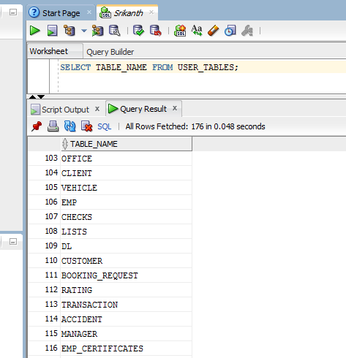

**Q.9**

**List of Table Constraints :**

**Office:**

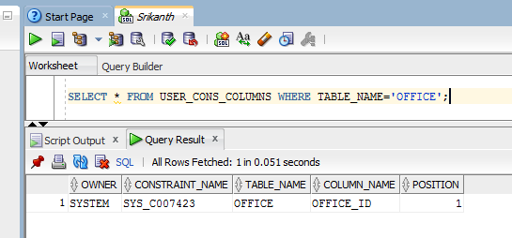

**CLIENT**

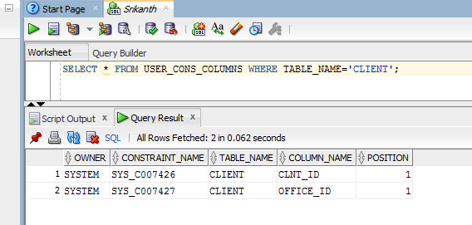

**VEHICLE**

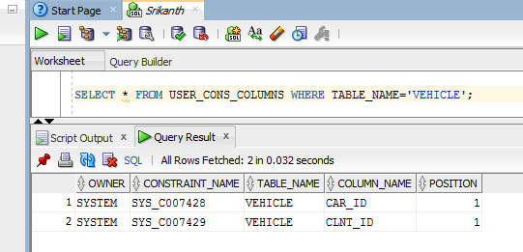

**EMP**

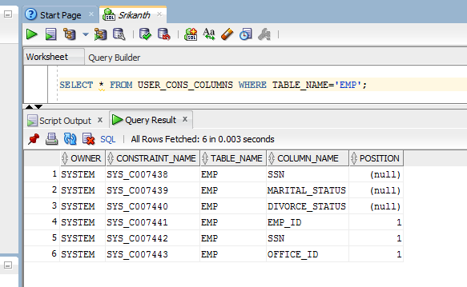

**CHECKS**

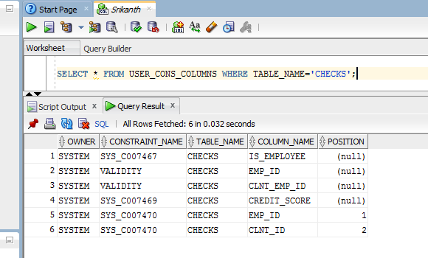

**LISTS**

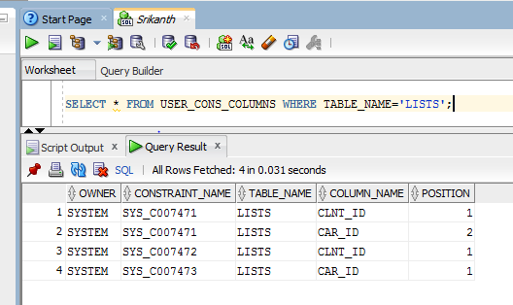

**DL**

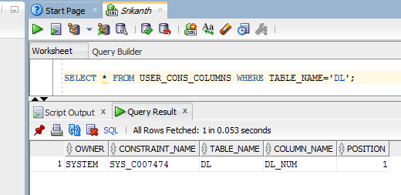

**CUSTOMER**

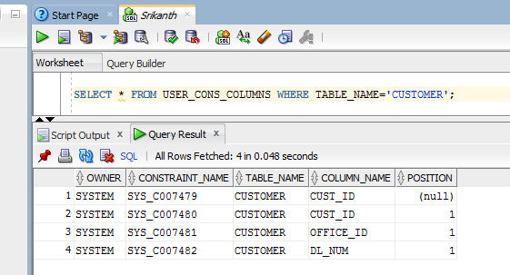

**BOOKING_REQUEST**

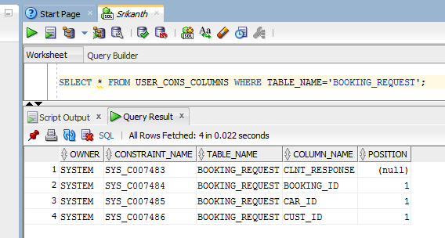

**RATING**

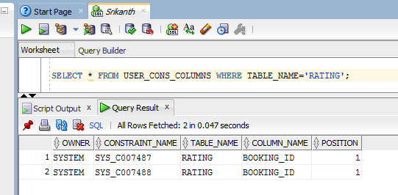

**TRANSACTION**

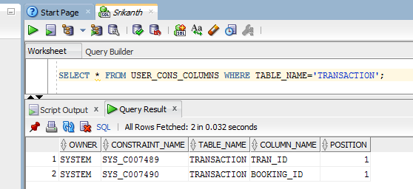

**ACCIDENT**

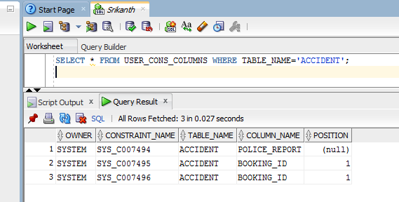

**MANAGER**

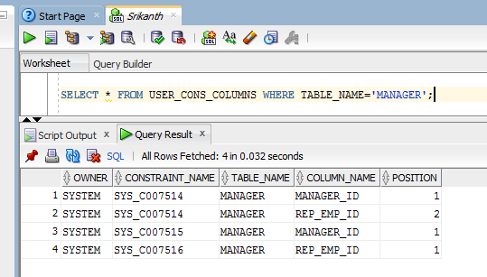

**EMP_CERTIFICATES**

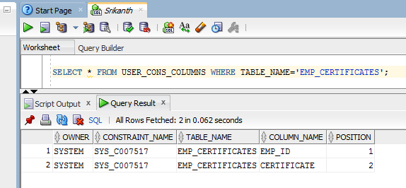

**10. List of Values on each table:**

**Office:**

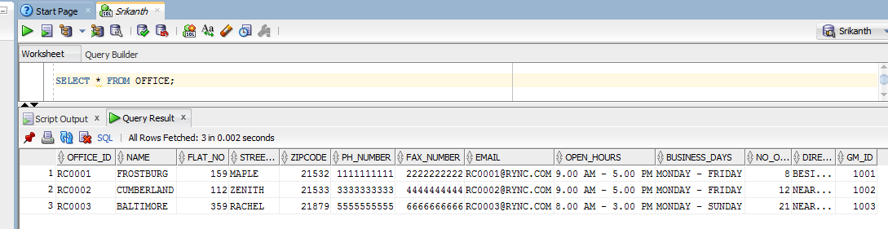

**CLIENT**

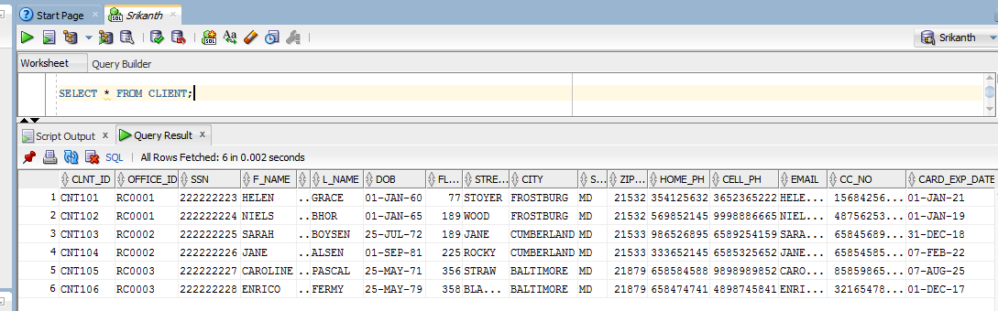

**VEHICLE**

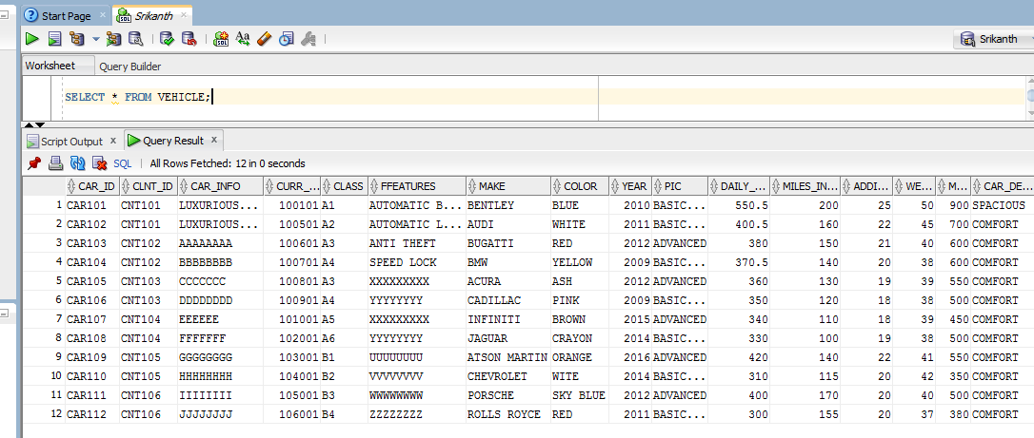

**EMP**

SCREENSHOT 1:

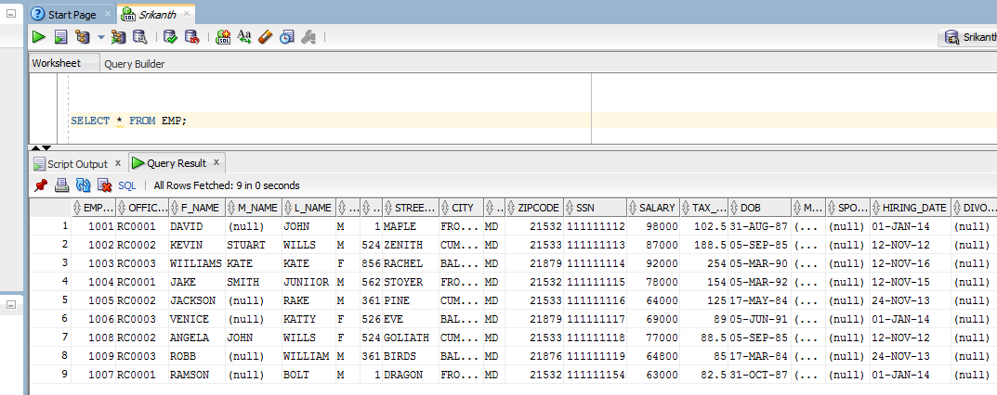

SCREENSHOT 2:

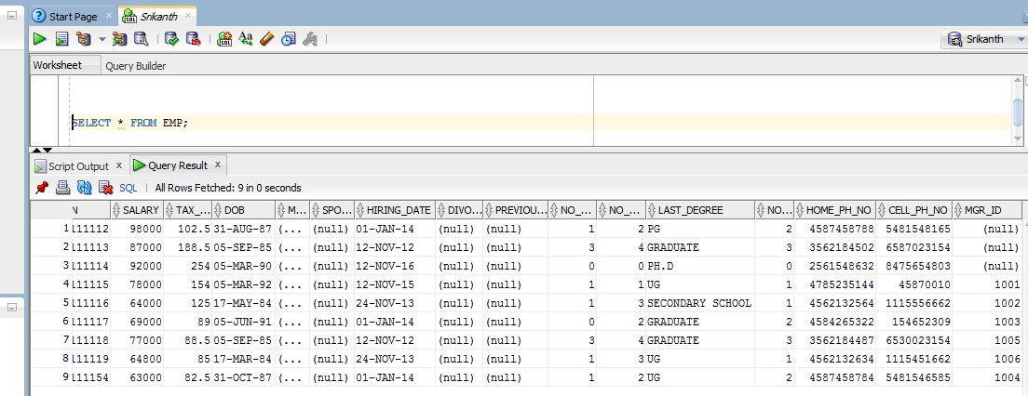

**CHECKS**

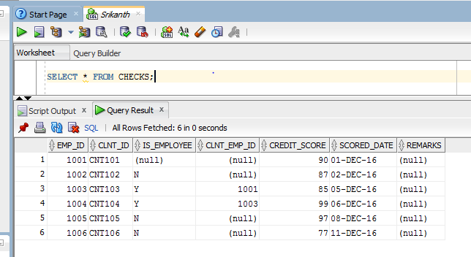

**LISTS**

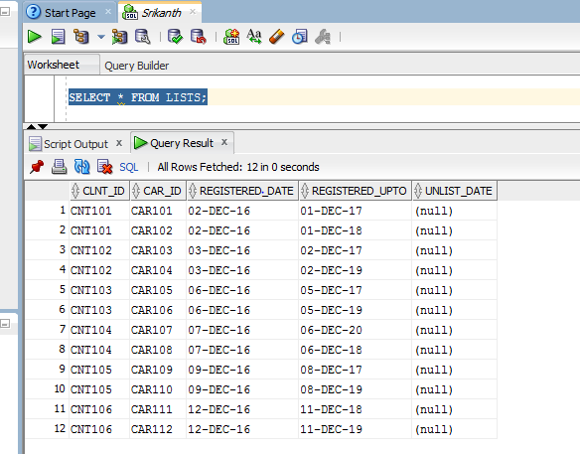

**DL**

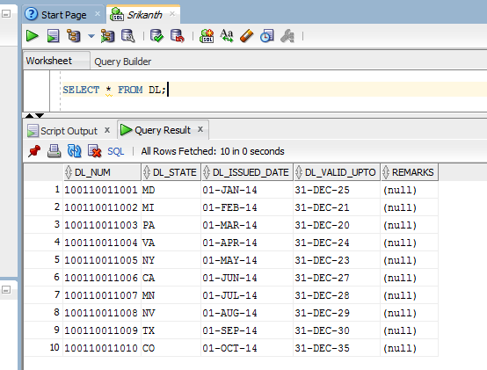

**CUSTOMER**

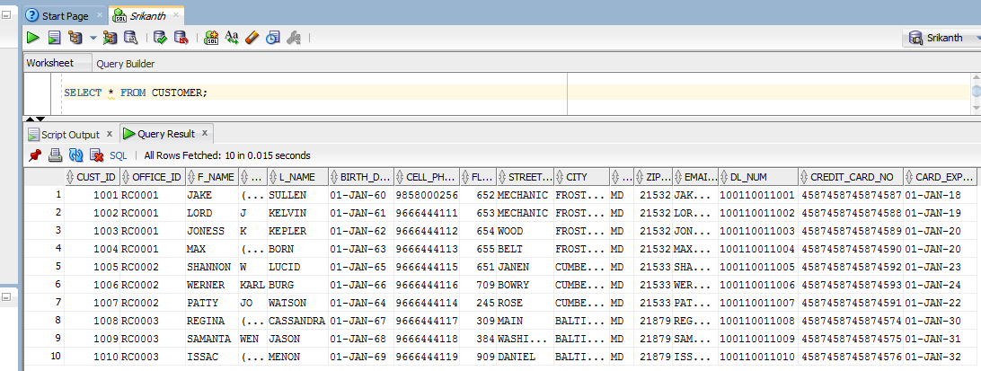

**BOOKING_REQUEST**

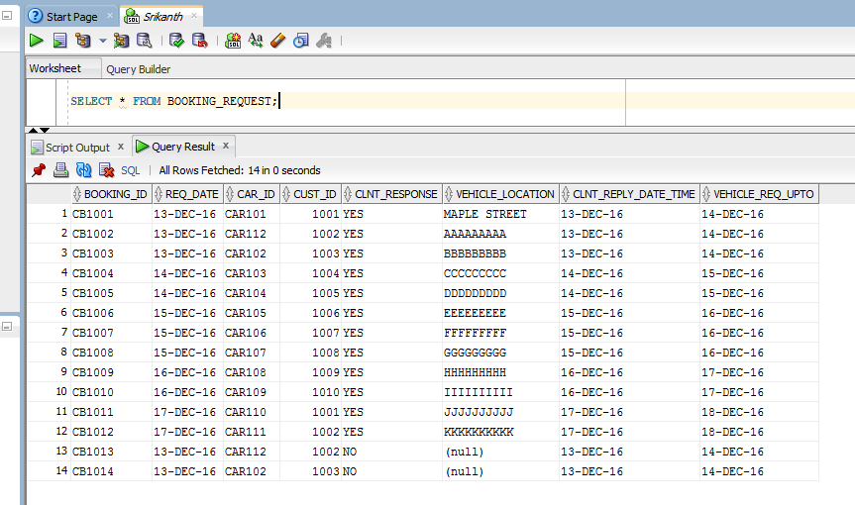

**RATING**

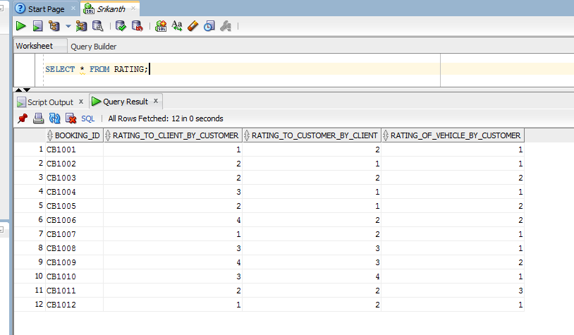

**TRANSACTION**

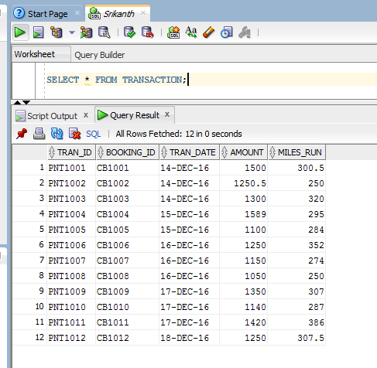

**ACCIDENT**

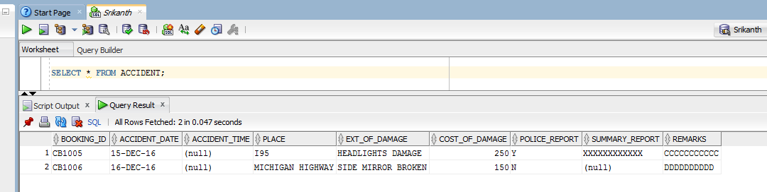

**MANAGER**

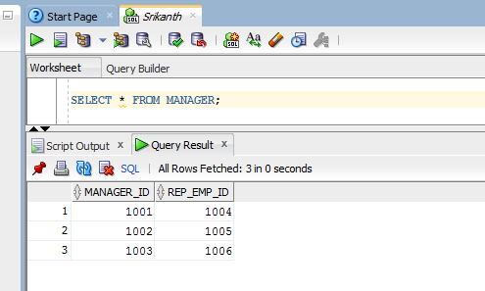

**EMP_CERTIFICATES**

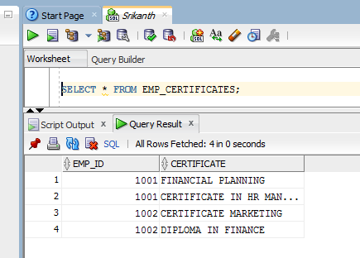

11 a. create mailing lables for employee ( name & address)

Query: SELECT F_NAME||' '||M_NAME||' '||L_NAME||', '||FLAT_NO||', '||STREET_NAME||', '||CITY||', '||STATE||', '||ZIPCODE AS MAILING_ADDRESS FROM EMP;

Output:

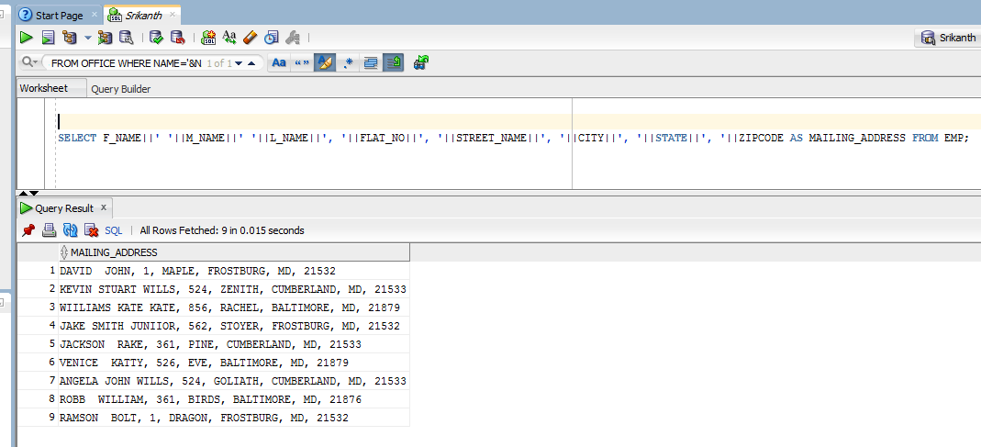

11 b. Display the name of employees that are office managers.

Query: SELECT F_NAME||' '||L_NAME NAME FROM EMP WHERE EMP_ID IN((SELECT MGR_ID FROM EMP) MINUS (SELECT GM_ID FROM OFFICE));

Output:

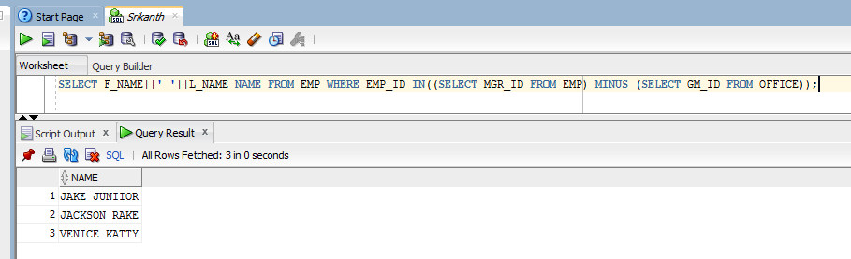

11 c. Display the first & last name of client with their credit score

Query:

SELECT A.F_NAME||' '||A.L_NAME AS NAME,B.CREDIT_SCORE FROM CLIENT A,CHECKS B WHERE A.CLNT_ID=B.CLNT_ID;

Output:

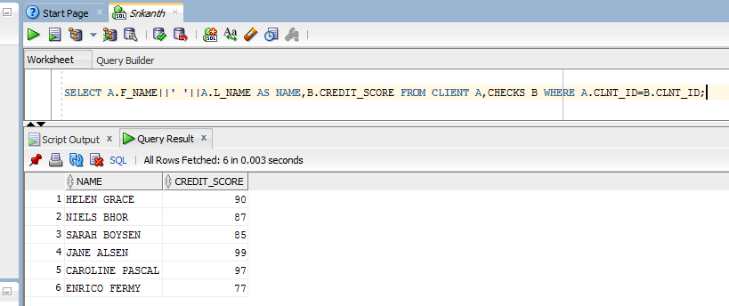

11 d.Display the name of client,name of employee, and the office name employee works at.

Query:

SELECT A.F_NAME||' '||A.L_NAME AS CLIENT_NAME,B.F_NAME||' '||B.L_NAME AS EMP_NAME,D.NAME AS OFFICE_NAME FROM CLIENT A,EMP B,CHECKS C,OFFICE D

WHERE A.CLNT_ID=C.CLNT_ID AND B.EMP_ID=C.EMP_ID AND B.OFFICE_ID=D.OFFICE_ID;

Output:

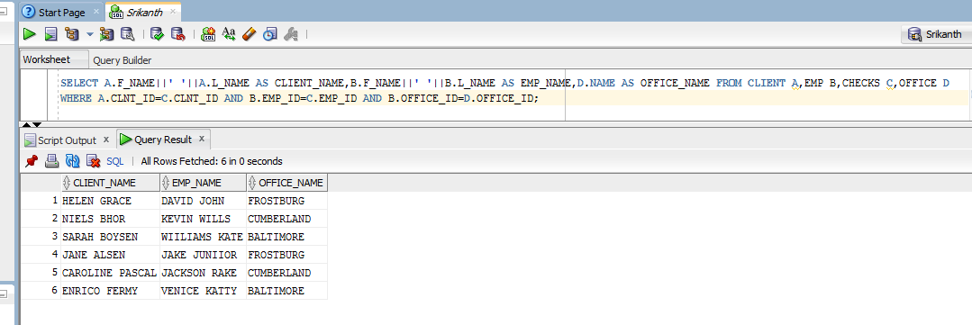

11 e.display name of customers who had accident,car id, and cost of damage

Query:

SELECT A.F_NAME||' '||A.L_NAME CUSTOMER_NAME,B.CAR_ID,C.COST_OF_DAMAGE FROM CUSTOMER A,VEHICLE B,ACCIDENT C,BOOKING_REQUEST D WHERE D.BOOKING_ID=C.BOOKING_ID AND D.CUST_ID=A.CUST_ID AND D.CAR_ID=B.CAR_ID;

Output:

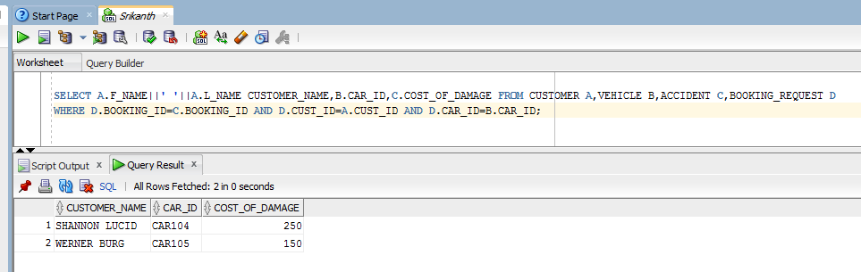

11 f. display total number of cars rented by each customer

Query:

SELECT B.F_NAME AS CUSTOMER_NAME,COUNT(*) AS NO_OF_BOOKINGS FROM CUSTOMER B,BOOKING_REQUEST A WHERE B.CUST_ID=A.CUST_ID AND A.CLNT_RESPONSE='YES' GROUP BY B.F_NAME;

Output:

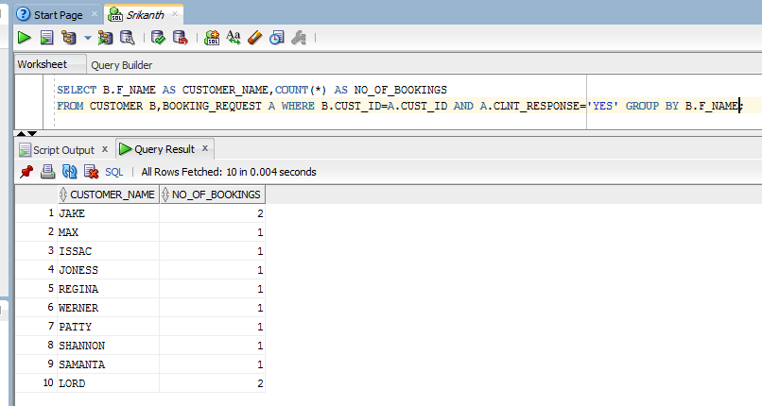

11 g.Display the number of employees for each office

Query:

SELECT A.OFFICE_ID,B.NAME AS OFFICE_NAME,COUNT(*) AS NO_OF_EMPS FROM EMP A,OFFICE B

WHERE A.OFFICE_ID=B.OFFICE_ID GROUP BY (A.OFFICE_ID,B.NAME);

Output:

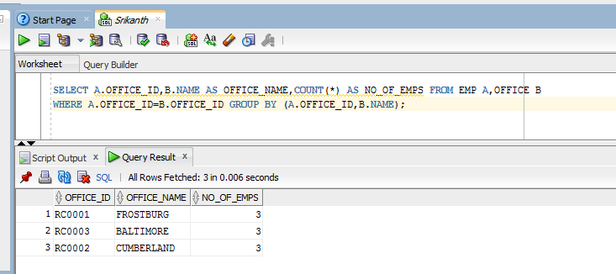

11 h.Dispaly name ,phone no of clients over 30 years old

Query:

SELECT F_NAME||''||L_NAME AS CLIENT_NAME,CELL_PH,HOME_PH FROM CLIENT WHERE ((SYSDATE-DOB)/365)>30;

Output:

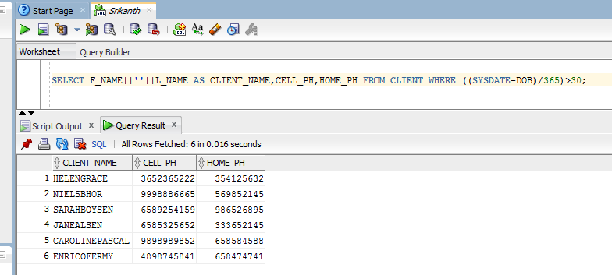

11 i.Dispaly SSN, address of female employees with more than one certificate

Query:

SELECT SSN,FLAT_NO,STREET_NAME,CITY,STATE,ZIPCODE FROM EMP WHERE GENDER='F' AND EMP_ID IN (SELECT EMP_ID FROM

(SELECT EMP_ID,COUNT(*) AS NO_OF_CERTS FROM EMP_CERTIFICATES GROUP BY EMP_ID) WHERE NO_OF_CERTS>1);

Output:

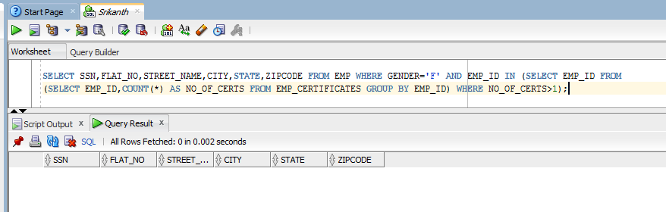

11 j.Dispaly the total number of cars listed on any day. User will inPut the date and time

Query:

SELECT LISTED_DATE,NO_OF_CARS FROM (SELECT REGISTERED_DATE AS LISTED_DATE, COUNT(*) NO_OF_CARS FROM LISTS GROUP BY REGISTERED_DATE) WHERE LISTED_DATE='&LISTED_DATE';

Output:

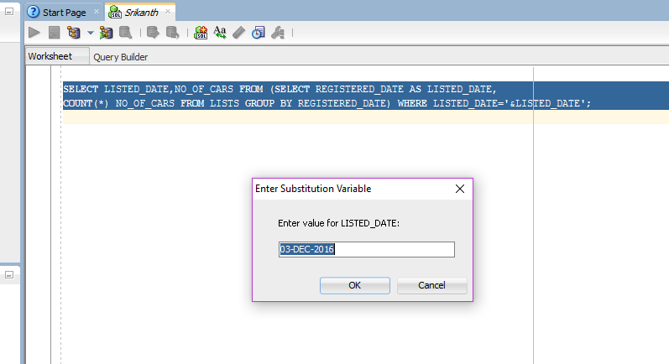

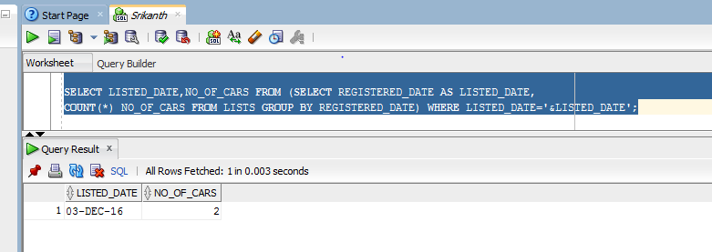

11 k.List the employee’ s name and clients name with score higher than 50 in 2017.

Query:

SELECT A.F_NAME||''||A.L_NAME AS EMP_NAME,B.F_NAME||' '||B.L_NAME AS CLIENT_NAME FROM EMP A,CLIENT B,CHECKS C WHERE A.EMP_ID=C.EMP_ID AND B.CLNT_ID=C.CLNT_ID AND C.CREDIT_SCORE>50 AND C.SCORED_DATE BETWEEN '01-JAN-2017' AND '31-DEC-2017';

Output:

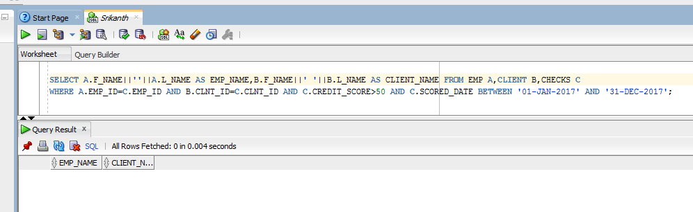

11 l. List of feedback ( client name, customer name, the rating number and who did rating)

Query:

SELECT A.F_NAME||' '||A.L_NAME AS CLIENT_NAME,B.F_NAME||' '||B.L_NAME AS CUSTOMER_NAME,C.RATING_TO_CLIENT_BY_CUSTOMER,C.RATING_TO_CUSTOMER_BY_CLIENT,C.RATING_OF_VEHICLE_BY_CUSTOMER FROM CLIENT A,CUSTOMER B,RATING C,BOOKING_REQUEST D,VEHICLE E WHERE C.BOOKING_ID=D.BOOKING_ID AND D.CAR_ID=E.CAR_ID AND E.CLNT_ID=A.CLNT_ID AND D.CUST_ID=B.CUST_ID;

Output:

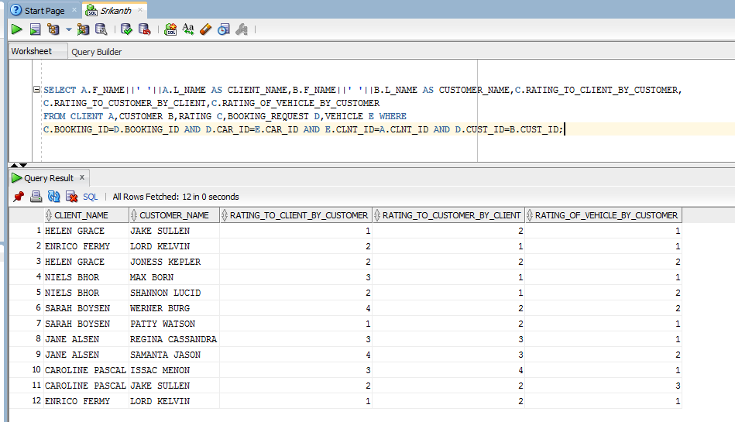

11 m.

The total number of time cars are rented, and the total cost of renting

Query:

SELECT CAR_ID,COUNT(*) NO_OF_TIMES_RENTED,SUM(AMOUNT) AS COST_OF_RENTING FROM (SELECT A.CAR_ID,B.AMOUNT FROM BOOKING_REQUEST A,TRANSACTION B WHERE B.BOOKING_ID=A.BOOKING_ID) GROUP BY CAR_ID;

Output:

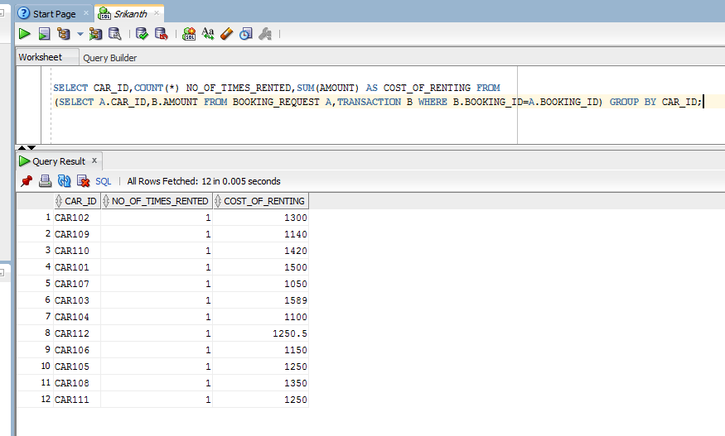

11 n.List employees’ name who is the manager of an office

Query:

SELECT F_NAME||' '||M_NAME||' '||L_NAME AS GM_NAME FROM EMP WHERE EMP_ID IN(SELECT GM_ID FROM OFFICE);

Output:

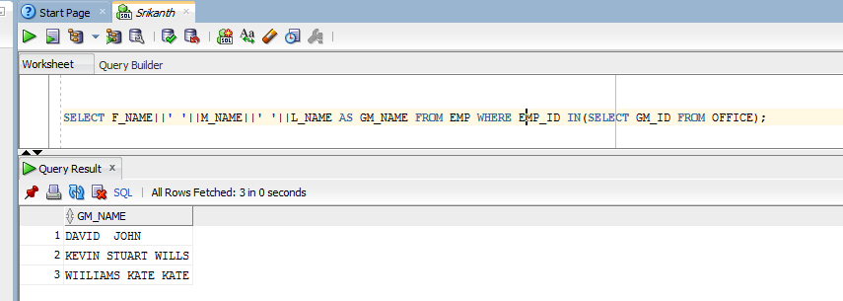

11 o.Search the database for a client .User input the data .Display client useful info.

Query:

SELECT CLNT_ID,OFFICE_ID,SSN,F_NAME,L_NAME,HOME_PH,CELL_PH,EMAIL FROM CLIENT WHERE CLNT_ID='&CLNT_ID';

Output:

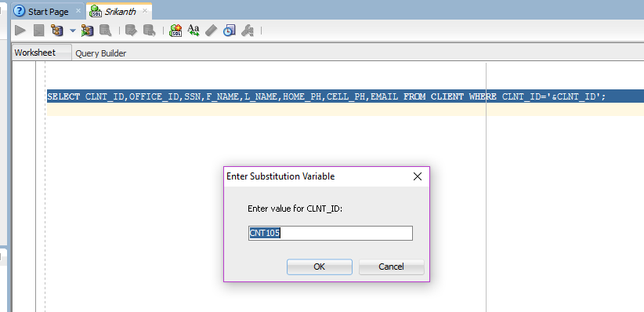

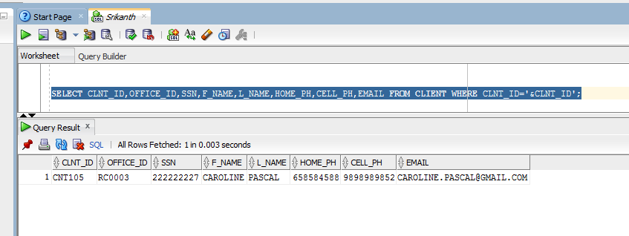

11 p

Total Salary of employee

Query:

SELECT EMP_ID,SALARY AS TOTAL_SALARY FROM EMP;

Output:

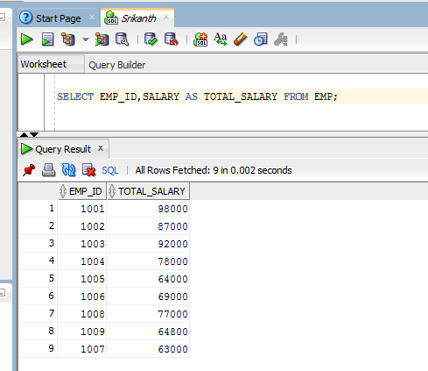

11 q.List employee names who also rented a car

Query:

SELECT EMP_ID,F_NAME||' '||L_NAME AS NAME FROM EMP WHERE EMP_ID IN(SELECT CLNT_EMP_ID FROM CHECKS WHERE IS_EMPLOYEE='Y');

Output:

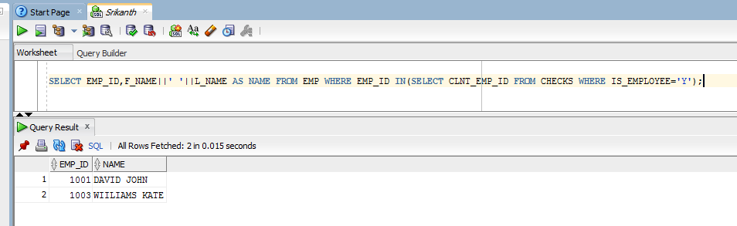

11 r.

Input the office name, display the operating days and hours

Query:

SELECT BUSINESS_DAYS,OPEN_HOURS FROM OFFICE WHERE NAME='&NAME';

Output:

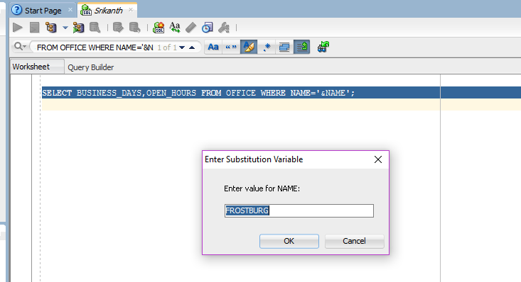

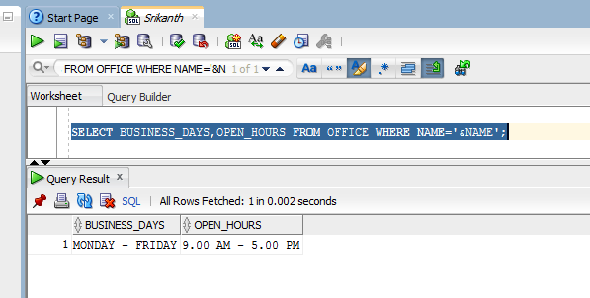

11 s.Dispaly the total mileage used in a given period.User input the start and end date

Query:

SELECT SUM(MILES_RUN) AS TOTAL_MILEAGE FROM TRANSACTION WHERE BOOKING_ID IN

(SELECT BOOKING_ID FROM BOOKING_REQUEST WHERE REQ_DATE BETWEEN '&REQ_DATE' AND '&REQ_DATE');

Output:

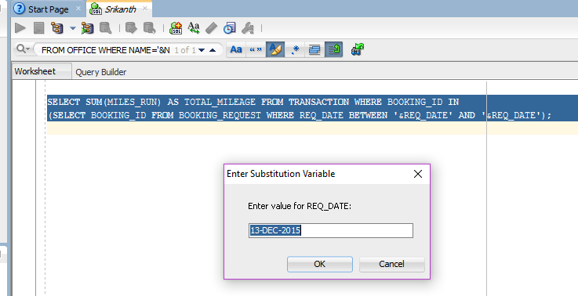

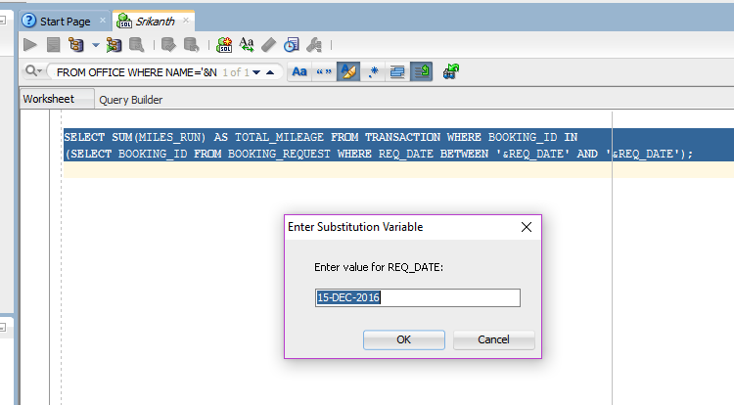

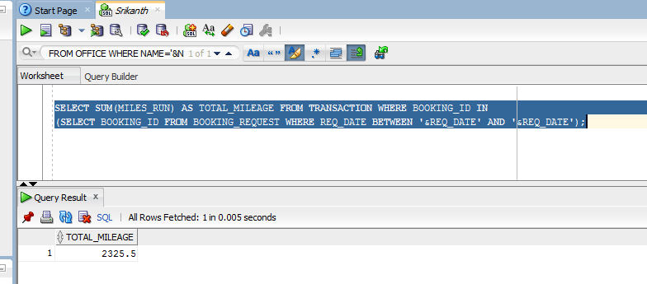

11 t. Write your own useful query to the customers.

Query:

SELECT A.CUST_ID,A.F_NAME||' '||A.L_NAME AS CUSTOMER_NAME,C.BOOKING_ID,B.RATING_TO_CUSTOMER_BY_CLIENT FROM CUSTOMER A,RATING B,BOOKING_REQUEST C WHERE B.BOOKING_ID=C.BOOKING_ID AND C.CUST_ID=A.CUST_ID AND B.RATING_TO_CUSTOMER_BY_CLIENT<=2;

Output:

